Telecom Location Management Using MapViewer

Bryan Teahan
Mar 2010
bryan.teahan@terralink.co.nz
Terralink International Limited

Abstract

With Telecom moving to a separated Business environment and the introduction of new systems and processes that support this separation, there is a need to have shared location and address validation data resources to manage their data more effectively.

Terralink was contracted to design, and build:
- a new database to automate the supply of geo-spatial data.
- a centralised repository for address information.
- tools for Telecom users to automatically verify and update new addresses.

Telecom’s Location Management project was responsible for providing this service and required Telecom to migrate existing location information and applications to a new database hosted on a shared Oracle Locator server architecture.

This database and application provides address updates and verification as well as replicating nightly the geo-spatial location data from Terralink International Limited.

The introduction of the new Oracle Locator server as a single master Location environment within Telecom:
- supports the separated application environments among Retail, Wholesale and Chorus.
- reduces the number of sources of address data throughout Telecom, as a single master to share common data among the business groups.
- provides a rules-based data update entry point for the creation of new and changed addresses within the current 2.73 million service address database.

The implementation of the Location Management project in two phases is presented describing Phase One which established the Location Management Server, with a fully populated and functional system running at Telecom and Phase Two which established the interfaces, including the Address GUI for address searching and maintenance.

This presentation describes the architecture using the Oracle Fusion Middleware MapViewer and the connection with the database PL/SQL procedure and triggers.

The MapViewer GUI is displayed showing how addresses are searched, created and maintained for all of New Zealand and how existing systems are integrated.

Some insights into the creation of a new database, application and software for a large corporation are also discussed.

Introduction

With Telecom moving to a separated Business environment and the introduction of new systems and processes that support this separation, there is a need to have shared location and address validation data resources to manage their data more effectively.

Terralink was contracted to design, and build:
- a new database to automate the supply of geo-spatial data.
- a centralised repository for address information.
- tools for Telecom users to automatically verify and update new addresses.

Telecom’s Location Management project was responsible for providing this service and required Telecom to migrate existing location information and applications to a new database hosted on a shared Oracle Locator server architecture.

This paper describes the solution that was built for Telecom by Terralink utilising the Oracle Fusion Middleware MapViewer.

Telecom’s Location Management Project
The project was broken into two phases:
- Phase One established the Location Management Server, with a fully populated and functional system running at Telecom with replication nightly of geo-spatial location data from Terralink to Telecom providing address updates and verification.
- Phase Two established the interfaces, including the Address GUI for address searching and maintenance.

Figure 1: Location Management: Project Phases

Phase One

A new Oracle Locator server was installed to create a single master Location environment within Telecom:
- supports the separated application environments among Retail, Wholesale and Chorus.
- reduces the number of sources of address data throughout Telecom, as a single master to share common data among the business groups.
- provides a rules-based data update entry point for the creation of new and changed addresses within the current 2.73 million service address database.

During this phase the following was implemented:
- Loading of address data.
- Loading of Terralink’s Terrabase data.
- Establishment of Oracle replication data flows between Terralink and Telecom.
- Implementation of triggers to manipulate Address data as required.
- Creation of a unique Telecom Location Code (TLC).
- Establishment of processes to transfer Location Management data into existing Telecom systems.
- Processes to load existing Telecom Address data into Location Management.

Phase Two

In this phase there was a detailed design and implementation of a Web-based Address GUI using Oracle MapViewer.

The Address GUI is able to:
- Search for Addresses.
- Create, update and delete Telecom Pseudo Addresses for all addresses not in Terralink’s physical address database (eg Phone box, Cell Tower).
- Display spatial data from Terralink’s Terrabase dataset required to provide context. This includes
  - Road information.
  - Address data.
  - Property Extents.
- Perform basic mapping application functions like Pan and Zoom.
- Print.
- Provide a method for notifying Terralink that a:
  - Terralink Address may require review by Terralink.
  - Telecom Pseudo Address that is being processed at Terralink needs to be updated.
For this phase, there were many features that were not in scope which may be implemented in future releases like adding points of interest, editing and modifying spatial data and providing an API.

Architecture
A new single-instance Oracle database was created on a new Location Management Server at Telecom. This uses Oracle v10.2.0.4 Enterprise Edition with the Oracle Locator Option, with a mirror for the Development database.

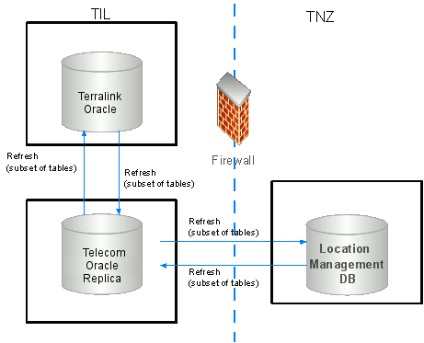

Figure 2: Architecture
The end-to-end data flow within Location Management is summarised as shown below:

Figure 3: End to End Data Flow

Data Model

Terralink maintains an integrated Terrabase dataset combining data from many sources. A Data Dictionary was built for Telecom who were provided with a subset of Terrabase to be replicated into their Location Management Server.
Figure 4: Core Data Model

Figure 4 shows the complicated nature of just one of the data models.

Data Sources included:

- Terralink Terrabase data of physical addresses and roads
- Land Information New Zealand’s Core Record System of cadastral data
- New Zealand Post’s Postal Delivery Addresses, postcode network file and GeoPAF
- Telecom Pseudo addresses and exchange boundaries.

The database contains five schemas:
- Terralink Location data (containing over 100 tables)
- Core cadastral data
- Telecom Location Management data
- Telecom administration (containing audit, log, system admin tables)
- Telecom exchange boundary data.

A feature of the model was the creation of a new Telecom Location Code (TLC) which is a static unique identifier assigned to all addresses in Location Management.
The intent of a TLC is that they are handed out to other Telecom systems, ensuring those systems obtain a correctly formatted address on demand from Location Management.
The TLC supersedes the prior identifier as the primary Telecom identifier to reference Service Addresses.

Oracle Replication
Oracle standard replication techniques along with specialised scripts are used to maintain all the systems. Spatial data in Location Management is replicated from Terralink ensuring Telecom has access to the most current data possible. Additionally new Telecom addresses (Pseudo addresses) are replicated to Terralink so they potentially can be adopted by Terralink. The replication is a fast refresh of changes only.

The following is also maintained:
- Oracle version
- Oracle Spatial SRIDs
- Coordinate systems (New Zealand Tranverse Mercator is used at Telecom requiring a projection from Latitude/Longitude)
- Data required for Telecom Smallworld GIS environment
- Metadata
The replication environment is established by the installation and commissioning of a Replication Server that sits between Terralink and Telecom. This server hosts an Oracle database and permits the adoption of a two-stage replication environment that eliminates the need for the two production servers having a direct database link with each other.
This design also simplifies the data flows, as there is the need to manipulate spatial projection systems between Terralink and Telecom.
During replication, If one of the key replication events or associated downstream triggers has failed, then both the Location Management and associated tables in Terralink must be returned to its initial state. This may mean rolling back transactions in other tables that have been already been committed.
Materialized views are created based on source tables in the Terralink database.
Transform tables are also used to contain spatial data transformed to the correct coordinate system, and these are updated from the materialized views after those have been refreshed.
Spatial indexes are created on relevant materialized views in all database instances.

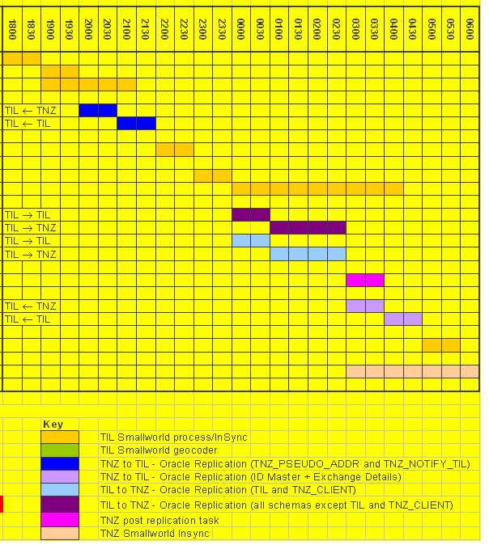
Figure 5: Nightly Jobs
The whole replication process requires certain jobs to be scheduled at specific times and is quite complicated with two-way flow of information. Figure 5 shows the complexity of when processes are run and having to ensure that each step has successfully completed before the next step is activated.

Address GUI

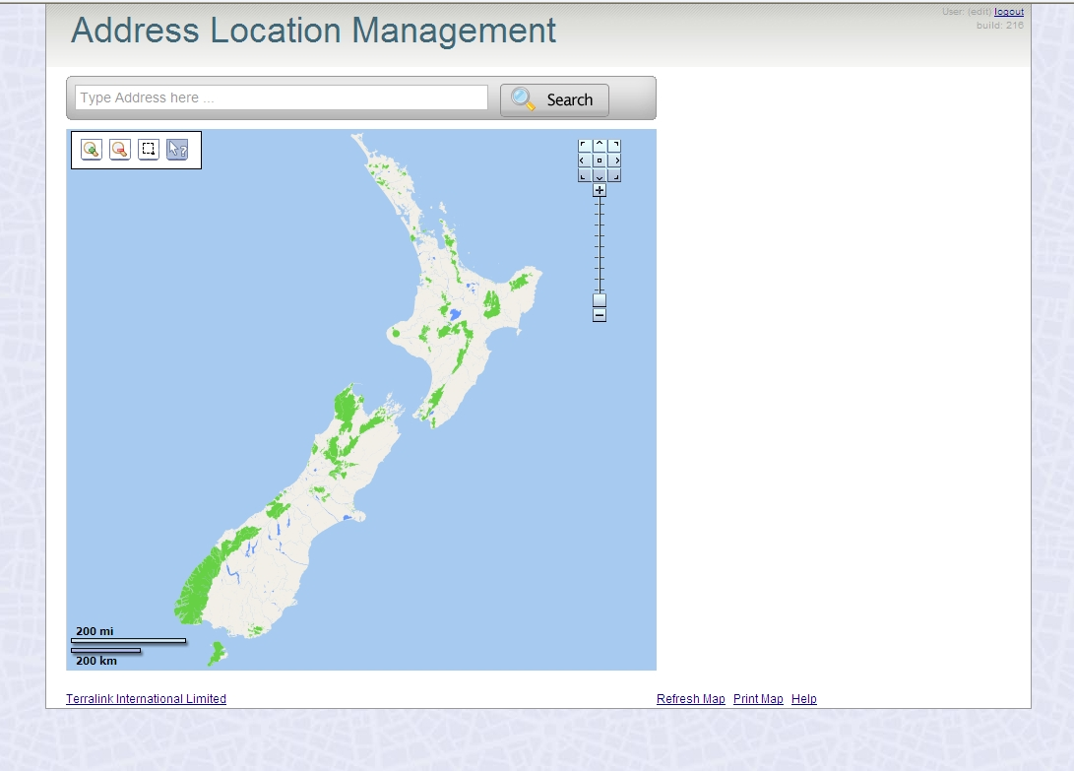
Figure 6: Address GUI
The business requirement for the Address GUI was to:
- Facilitate Service Order request.
  - Find Address
  - Verify Address
  - Create and maintain Pseudo Addresses.
The technical requirements for the Address GUI were as follows:
- Web Service that uses the standard Telecom internet browser.
- The minimum web browser standard is Internet Explorer v6 and Firefox v3.
- Rule based resulting in creation of high-quality Telecom Pseudo addresses.
- Functionality controlled by user permissions.
Auto-Complete address searches use a predictive text searching method that takes the user’s input and presents a list based on the search’s result set (shown in Figure 7 below):
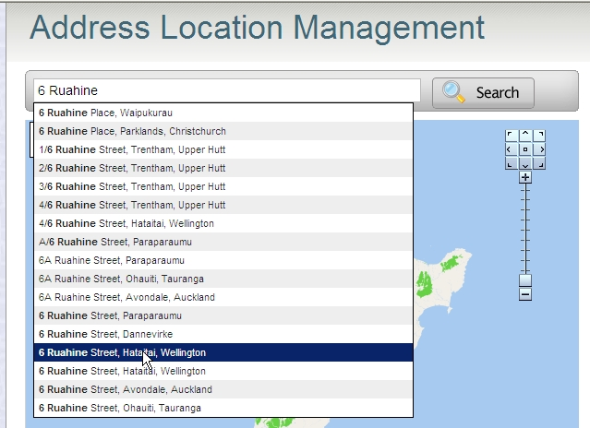
Figure 7: Auto-completion of a search
Data is drawn on the Map Display using standard Terralink symbology and labelling.
Addresses have different symbols and colours depending on the type of address:
- Telecom Pseudo Addresses
- Terralink Address
- Greenfield Subdivision Address
- Telecom Network Object
Addresses are also labelled.

The following map layers are also shown:
- Roads. (Labelled with Road Name at appropriate map scale)
- Property extents. (Not labelled)
- Suburbs. (Labelled as required)
- NZ Coastline. (To provide context)
- Points of Interest. (Labelled)
- Land usage. (To provide context)

The following shows some examples of the Address GUI:

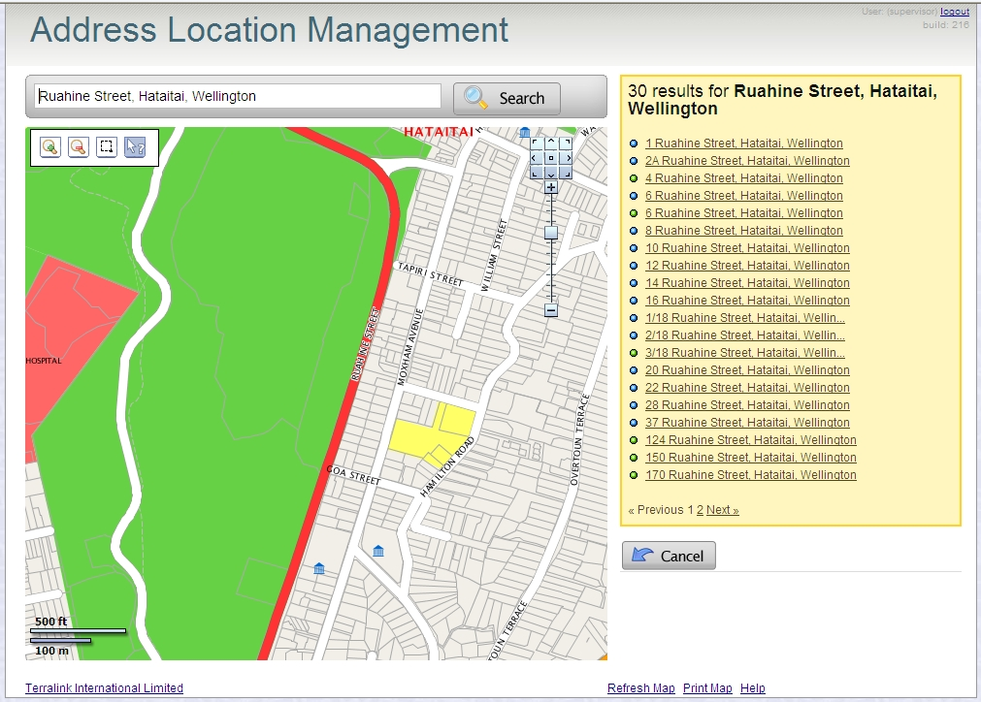
Figure 8: Ability to search and show all addresses in a street

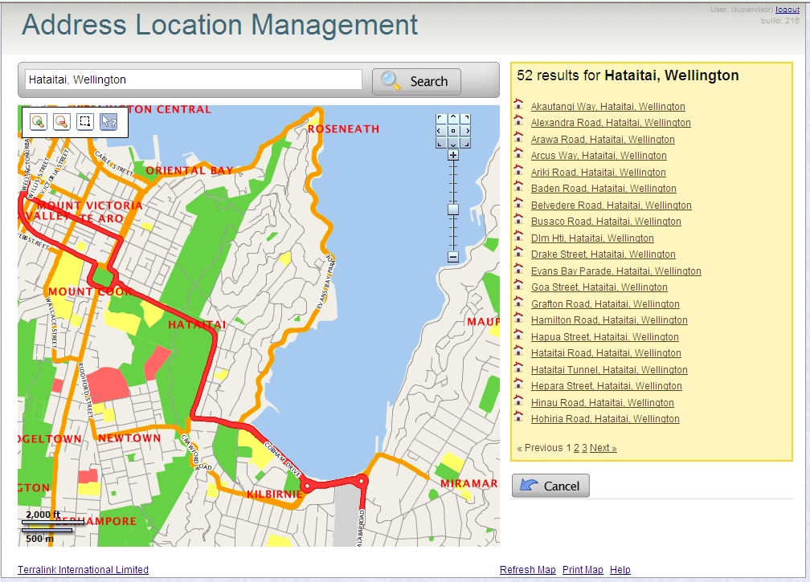
Figure 9: Ability to search and show all roads in a suburb or town

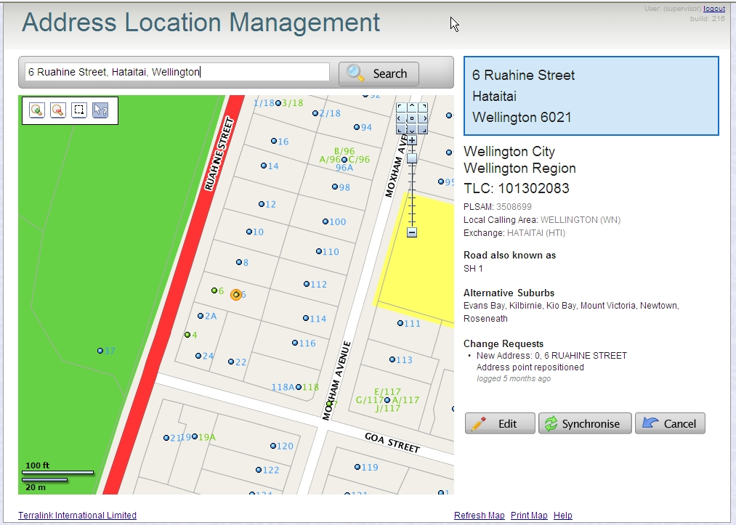
Figure 10: Detailed location information about an individual address

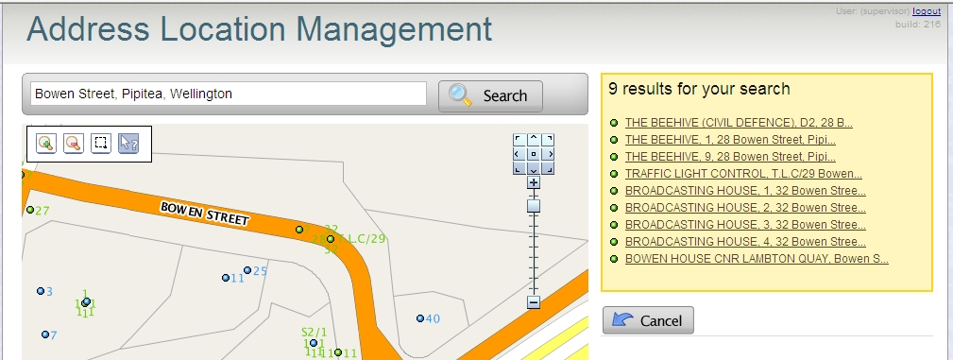

Figure 11: Telecom pseudo addresses near the Beehive

Address GUI Technology
The following components make up the Address GUI:

Oracle Locator
Oracle Locator is a feature of Oracle Database Standard and Enterprise Editions that provides core location functionality needed by most customer applications.
Oracle Spatial is an option for Oracle Enterprise Edition that provides advanced spatial features to support high-end GIS solutions.
Telecom Location Management uses Oracle Locator as only core functionality was required and it was a cheaper option.

Oracle Application Server
Oracle Application Server is part of Oracle’s Fusion Middleware technology stack. The heart of Oracle Application Server consists of Oracle HTTP Server (based on Apache HTTP Server) and OC4J (OracleAS Containers for J2EE) which deploys J2EE-based applications.

Oracle MapViewer
Oracle Fusion Middleware MapViewer is an Oracle Application Server Java component and JDeveloper extension used for map rendering and viewing geospatial data managed by Oracle Spatial or Locator.

At the start of the project, various platforms were chosen to be evaluated to determine the best software to meet the business requirements:
- GE GeoXtension
- iSmart
- MapXtreme
- ERDAS ADE
- Oracle MapViewer

Oracle MapViewer was chosen as the best tool for the project for the following reasons:
  - GeoXtension only supported Microsoft Internet Explorer and required a SVG-plug in the client browser.
  - iSmart was not evaluated as the vendor did not reply to Terralink’s emails.
  - MapXtreme required a graphics card in the Application Server.
  - It was felt that Location Management would use only a fraction of ERDAS ADE capabilities and there were concerns over the stability of the ADE Java applet and ADE was slow to load geometries.
  - Oracle MapViewer met all the requirements. It has no capability to insert or maintain spatial objects like points, line or polygons. However, the ability for the Telecom user to create and manage points that represent Address locations is provided by calling the PL/SQL procedures developed by Terralink.

Oracle MapBuilder
Oracle MapBuilder is part of the Oracle MapViewer product and is used by DBA-level users to define cartography, symbols and styles. It was used by Terralink to define all the cartographic styles required for the Address GUI.

Development Environment
The development approach was to deploy into Oracle Application Server J2EE container a java compliant application built using JRuby and the popular web optimised open source framework ‘Ruby on Rails’ environment. This allowed developers to leverage the advantages of the J2EE environment, logging, database connectivity/connection pooling, security and memory constraints of the container whilst having a development environment optimised for quickly building robust and scalable web applications.
The advantage of JRuby is that development is faster as the developer can code and test the application at development time from within Ruby. The application is compiled to Java only when required. The alternative is to develop in a pure Java environment. In this case, the developer needs to compile the Java classes against the OAS j2EE container, slowing down development cycles.

The connection between the Java-Ruby environment and the Java Web Technology is bridged by a web servlet filter component called Jruby-rack. This handles Java requests, and routes them to the correct ruby handler along with all request/response and environment information.

The core rendering engine connects to the Oracle database through Java Database Connectivity (JDBC). It also reads the map metadata (such as map definitions, styling rules, and symbologies created through the Map Builder tool) from the database, and applies the metadata to the retrieved spatial data during rendering operations.

The map metadata (such as map definitions, styling rules, and symbologies) is stored in the Oracle database in specific views owned by MDSYS. These definitions were created by Terralink using the MapBuilder tool. These views were then exported and loaded into in the production Location Management database from the Terralink development database.

The Map Definition Tool is used to create and manipulate styles, themes, and base maps. The Map Definition Tool automatically inserts and manages mapping metadata in Oracle, for the styles, themes, and base maps it creates. The mapping metadata is inserted into the dictionary views user_sdo_styles, user_sdo_themes, and user_sdo_maps.

Security

Security is handled external to the application by a reverse proxy security module maintained by Telecom (SSO) which has a Sun Policy Agent installed. The policy agent allows users who have been assigned access to the application – and forwards the requests on to the application with the appropriate request environment headers set. The headers indicate the role the user is assigned to and the login name of the user.

PL/SQL Package

The interfacing between MapViewer and the Oracle Location Management database was implemented using PL/SQL packages.

Currently, the code base is up to version 156 in source control, with release 3 version 27 soon to go into production. The Package code currently contains about 9000 lines.

Standard PL/SQL functionally was predominantly used utilising global constants, global cursors, procedures and functions. Full debug and audit features can be turned on / off as required and there is separate provision for a training environment.

Only a few features of Oracle Locator were required in the implementation:

- Point-in-polygon (SDO_RELATE, SDO_EQUAL),
- Creation of points (SDO_GEOMETRY),
- Nearest neighbour (SDO_NN),
- Coordinate values (SDO_ORDINATES, SDO_UTIL.GETVERTICES)

Exception handling is used to log all error messages to a log table.

Several procedures from the package are utilised in triggers for address searching, auto-completing of a search, and editing and adoption of addresses at Telecom and Terralink.

Separate processes also run for the synchronisation of addresses and abbreviations with Telecom existing internal systems.

A separate PL/SQL package has been written to interface internal Telecom services to Location Management using JDBC calls to Stored PL/SQL procedures.

Insights

For a project of this scope and magnitude there will always be many trials and tribulations and many stories to tell.

From my perspective, there was an amazing amount of work performed by highly motivated Telecom and Terralink staff under pressure with everyone dedicated to implementing a quality, robust and reliable system.

Terralink has an agile environment which is flexible to changing requirements and was able to perform required changes and bug fixes quickly. However in an environment like Telecom’s it is critical that a rigid procedure is followed through development, staging, testing and production as there are huge consequences when a system fails.

The systems at Telecom are risk adverse and this would sometimes impede the implementation process. Coupled with this, we were implementing close to Christmas with impending critical deadlines where there also was a brownout and blackout at Telecom where no changes could occur.

The testing process was tedious where diligent testers treated all software as a black box and would sometimes not allow changes to be made quicker. They obviously did their job well as the application was eventually the application within Telecom to run the longest without a Severity-1 fault.

It was a relief and a time to celebrate when the application was finally in production with a job well done.

Summary

The Telecom Location Management project created a reliable, consistent and efficient tool for location and address data management. This system which utilises geo-spatial functionality via an Oracle Locator data model and Oracle MapViewer is already providing benefits to Telecom with improved levels of service and increased efficiencies through high data quality. The project was a major undertaking for Terralink where the most difficult part of the implementation was interfacing with existing systems but ultimately the solution was provided on time and within budget.

Acknowledgements

Many thanks to the members of the Terralink project team (Emily Willard, Chris Weir, Dave Cook, Kwasi Afosa, Marcus Baguley) and to Shelley Crawford, Ken McGeady and the staff at Telecom. Much of the material for this article has come from the design and as-built documentation created for the project.

Further Reading

Oracle Spatial & Oracle Locator
http://www.oracle.com/technology/products/spatial/index.html

Oracle MapViewer online documentation:
http://www.oracle.com/technology/software/products/mapviewer/index.html

Oracle Fusion Middleware MapViewer:
http://www.oracle.com/technology/products/mapviewer/index.html

Oracle Mapviewer – All things Oracle Mapviewer:
http://oraclemaps.blogspot.com

Oracle Fusion Middleware Mapviewer Primer – An Oracle White Paper Nov 2008:
http://oraclemaps.blogspot.com/2008/11/official-mapviewer-white-paper-primer.html

Oracle Spatial Documentation:
http://www.oracle.com/technology/documentation/spatial.html

Mapviewer Datasheet:
http://www.oracle.com/technology/products/mapviewer/pdf/mapviewer_datasheet_11gr1.pdf

Creating Themes and Choosing Styles:
http://www.oracle.com/technology/obe/obe_as_10g/deploy/mapviewer/mapviewer.htm#dm3

JRuby
http://jruby.org/

